Core Highways Release Notes
Release 4.0.2.1
Incl Quad Tree Addendum for 9i Systems

Contents
Contents 2
1.1 Author 3
1.2 Document Summary 3
1.3 Document History 3
1.4 Reference documents 3
1.5 Distribution 3
1.6 Quality Assurance 3
3.1 Key Metadata Changes 5
NM_BASE_THEMES and NM_NW_THEMES metadata 5
3.2 Subordinate user metadata 6
Access to Tables and Views 6
Oracle Metadata 6
SDE Metadata 6
3.3 Support for date-tracked datum (join) views 6
3.4 Metadata Checking. 7
Execution of scripts 7
List of checks 8
    - Theme checker (nm3sdo_check.run_theme_check) 8
    - SDO checker (nm3sdo_check.run_sdo_check) 8
    - SDE checker (nm3sde_check.run_sde_check) 8
    - SDO Check - Example Output 9
    - Theme Check – Example Output 10
    - SDE Check – Example Output 11
3.5 Performance Changes 12
3.6 Support for Quad Tree Indexes 12
3.7 Date tracking dynamically segmented layers. 12
3.8 Other Changes 12
4.1 Customer Raised Issues 13
5.1 Test Script 14
5.2 Converting R Tree Indexes to Quad Trees 15
5.3 Converting Quad Tree indexes to R Trees 15

- Document Control
  - Author
Rob Coupe, Technical Architect

  - Document Summary
This document provides a description of the changes in this release and information about how these changes may impact on an Exor installation.

  - Document History

Document History
Revision | Date | By | Description
1 | 11-Jul-2008 | Exor Development | First Edition

  - Reference documents
None

  - Distribution
Exor Customers, Partners and Staff

  - Quality Assurance
Document Details
File | Prepared By
0000.doc | Rob Coupe
Document Name | Reviewed By
TMA Manager Release Notes v4.0.4.6 | Marc Kratzschmar
Version | Approved for issue by
1.0 | Rob Coupe
Date of Issue
26-Jun-2008

- Introduction
This document highlights the key changes to the exor Core Highways database following the release of Core Highways v4.0.2.1. It is specifically targeted at spatial systems users and system administrators of the exor systems. Changes in the core database functionality have the potential to have wide impact across all exor applications and it is important that these changes are understood. However, many of the functions of exor Core Highways are extremely technical in nature and this document is aimed at those with some degree of technical knowledge and not at end users.

It is not intended to be a full system description but a guide to indicate what changes have been made, why they have been made and the potential failings if this upgrade is not applied.

The changes in this release are not compatible with the 4020 version of UK Street Gazetteer Manager. It should be noted that some major improvements in this product have been implemented on the 4.0.4 stream of releases on Oracle 10g release 2 so this restriction is not thought to be significant. If you use UK Street Gazetteer Manager on a 4.0.2.0 platform then please contact support before applying this patch.

After reading through this document, should you have any need for training or consultancy then please contact your exor account manager. If these changes are considered important for your current release and this is incompatible with 4.0.2.0 then please contact exor support.

This patch is intended to be used in conjunction with Spatial Manager <Release No.>

- New Functionality
This Chapter describes the main areas of functionality that have been changed in this release.

- Themes metadata changes
- Subordinate user metadata changes
- Support for date-tracked datum (join) views.
- Metadata checking.
- Performance improvements.
- Support for Quad Tree Indexes
- Date tracking dynamically segmented layers.
- Other changes

The primary purpose of this release has been to make corrections to the core and spatial server systems in the areas of date-tracking datum spatial layers and in the support of subordinate users.

A list of the logs that are known to be cleared by these changes is given in the Log No Summary chapter.

  - Key Metadata Changes
NM_BASE_THEMES and NM_NW_THEMES metadata

Changes implemented in recent releases included the construction of a date-tracked view to deliver the spatial representation of base network data (or datum spatial layer). In order that the relationship between datum and dependent asset and group layers, that is those that are dynamically segmented from measures relative to the datum layer, is consistent, it is important that the NM_BASE_THEMES table contains a reference to the actual base table and not the date-tracked view. During recent upgrades, the data within the NM_BASE_THEMES table made reference to the date-tracked view. This situation has been exacerbated on some customer sites by the inclusion of further join-views whereby the datum layer is represented by a join between an attribute only table and a spatial only table. The generation of new layers from the dynamic segmentation relative to the network would then register the correct metadata.

This has had several potential issues. Having modified the metadata to hold the reference to the date-tracked or join view in the NM_BASE_THEMES table, the Spatial Manager product may not have been able to allow the user to locate an asset relative to the network layer. This is due to the display being a date-tracked view whereas the base theme reference may be pointing to the base table. Also, the logic to change the dependent affected shapes when a datum is reshaped would only be performed on those dependent layers that reference the base table. This had the potential of a datum reshape leaving dependent shapes out of sync.

In the case where join views have been added and used in conjunction with earlier releases of Spatial Manager the reshape process could lead to loss of data or constraint violations as datum shapes were reshaped.

The addition of the date-tracked and/or join views also left multiple records in the NM_NW_THEMES table. This table holds the relationship between a spatial representation and the network data that it represents. This table is used to determine how to perform the dynamic segmentation of asset and group layers and hence having multiple records in this table can lead to the construction of multiple representations of the same asset or group.

The upgrade script for Core Highways 4.0.2.1 will ensure that the NM_BASE_THEMES data is correctly referencing the base table theme and not the date-tracked view theme. The changes to the server code will allow the system to be configured with multiple any number of themes to exist to represent a datum layer so date-tracked and/or join views are fully supported.

  - Subordinate user metadata

It has been noted from several logs that in some circumstances the metadata required to allow subordinate users (not the highways data owner) to gain access to spatial data has been left incomplete. This data is in several components.
- Access to Tables and Views
- Oracle metadata
- SDE Metadata

Access to Tables and Views

The subordinate user gains access to spatial tables through the use of views that are privately registered under the subordinate user schema. The use of public synonyms and private synonyms has been seen to cause problems in some areas and views provide the most reliable approach. Also, access through views is gained through the use of theme roles and the allocation of the theme role to a subordinate user. In previous releases, the access to a theme that was based on a view was not correctly administering the access to the underlying objects within the view.

The core Highways 4.0.2.1 provides checking scripts to report occurrences of failure to access the relevant tables and views and any failures can be repaired by touching the theme roles data. This can be achieved either be removing and adding a theme role or by revoking and re-granting a role to a specific user inside the exor modules. Any private synonyms will be replaced by privately owned views thus over-riding any existing public synonyms should they be employed. The changes to the server code will keep the access to tables and views in a manner that is consistent with the roles that have been granted to users and allocated to themes.

Oracle Metadata

In all matters relating to Oracle Spatial, it is fundamental to ensure that the user has access to Oracle metadata in the USER_SDO_GEOM_METADATA view. In previous releases, the server code could leave a subordinate user with the registration allowing access to spatial views but not always the underlying objects within the view. This meant that in some cases, the subordinate user may not have been able to perform spatial queries on the base table data.

The core Highways 4.0.2.1 provides checker scripts to report on any discrepancies in relation to the data in the subordinate users USER_SDO_GEOM_METADATA. Any such discrepancies can be repaired as described above by revoking and re-granting a role from/to a theme or from/to a specific user. The changes within the server packages will maintain the data in a state that is commensurate with the roles allocated to the themes and to the subordinate user.

SDE Metadata

Users of Spatial Manager require extra metadata to be able to access spatial representations of highways objects inside map. The spatial server part of core registers this metadata at the same time as the Oracle metadata. As above, in some cases, the SDE metadata was left in an inconsistent state for some subordinate users and in some case, the SDE registration of views may be in place but that of the underlying objects of the view may not have been present.

The Core Highways 4.0.2.1 provides a checker script that will report on any discrepancies with the SDE metadata. This data will be refreshed as described above. The changes to the server code will maintain the metadata in a state that is commensurate with the roles applied to the themes and to the users as well as the settings that direct SDE metadata to be used.
  - Support for date-tracked datum (join) views
The changes within the themes metadata allow the system to navigate to the base table to perform spatial queries fully utilising the power of Oracle Spatial. This allows exor services consultants to configure date-tracked and join views as required by the customers to improve the quality of the data within their spatial clients. In particular, when date-tracked views are employed spatial edits and dependencies are properly assessed. Also, the information being extracted from any join view will now be available more efficiently due to some performance improvements in the server code. These improvements should affect some queries in Spatial Manager but will have the most dramatic effect inside the web-mapping environment (for example the locator form) when identifying the nearest feature. As mentioned earlier, corrections have been made in the dynamic segmentation so the introduction of date-tracked or join views have no impact on the result set. Spatial Manager will now allow a user to configure a date-tracked or join view for a specific network type and still locate the asset relative to it. In prior releases, the system would force the client Spatial Manager tool to have the base table theme displayed. Using a date-tracked view prevented the location from being successful.

On starting Exor maps, some code executed to establish scale data for the scale bar. With a date-tracked view in place this was taking an inordinate amount of time. This had been made available as a previous patch on 4.0.4 systems but it has now been back-ported into 4.0.2.1
  - Metadata Checking.

The product is enhanced with new packages to provide listings of errors and warnings in the integrity of the metadata. Some of these warnings have no impact on the operation of the code but form a useful test. Others are critical to the correct functionality of the spatial tools and need to be addressed. There are three check procedures inside two packages. Each caters for one of the three forms of semi-dependent metadata namely the exor Themes data, the Oracle metadata and the SDE metadata. Each report is delivered to a specified location. There are two packages.

- nm3sdo_check
- nm3sde_check.

Nm3sdo_check reports exor Themes checks, and Oracle Spatial metadata.
Nm3sde_check reports on ESRI SDE metadata (where applicable)

Execution of scripts

Each method requires two parameters – pi_location and pi_filename
Pi_location must be a file system directory on the database server
Pi_filename is the name of the report produced and will be deposited in this directory/folder

To execute the check on Oracle (SDO) Metadata use the following command from a suitable interface such as TOAD, SQL Developer or SQL*Plus.

SQL> exec nm3sdo_check.run_sdo_check (‘/home2/download/utl_file’,’<user>_sdo_check.txt’)

The SDO metadata check has an optional Boolean flag to skip a check for unrecognised Geometry types. This can be used to improve the performance of the check.
To skip the Gtype check, pass in TRUE as a 3rd parameter.

SQL> exec nm3sdo_check.run_sdo_check (‘/home2/download/utl_file’,’<user>_sdo_check.txt’, TRUE)

To execute the Esri (SDE) metadata check, use the following command from a suitable interface such as TOAD, SQL Developer or SQL*Plus

SQL> exec nm3sde_check.run_sde_check (‘/home2/download/utl_file’,’<user>_sde_check.txt’)

To execute the Exor theme validation check, use the following command from a suitable interface such as TOAD, SQL Developer or SQL*Plus

SQL> exec nm3sdo_check.run_theme_check (‘/home2/download/utl_file’,’<user>_theme_check.txt’)
List of checks

Theme checker (nm3sdo_check.run_theme_check)

Themes that are not based on SDO layers
Themes that have a NULL Theme table
Themes that have a NULL Feature table
Themes that have an unsuitable PK/FK combination
Themes that reference a non-existent RSE table
Themes that reference a non-existent RSE FK column
Themes that reference a non-existent Label Column
Themes that reference a non-existent PK column
Themes that reference a non-existent Start Chain column
Themes that reference a non-existent End Chain column
Themes that reference a non-existent X coordinate column
Themes that reference a non-existent Y coordinate column
Themes that reference a non-existent feature PK column
Themes that reference a non-existent feature FK column
Themes that reference a non-existent feature shape column
Themes that reference a non-existent start date column
Themes that reference a non-existent end date column
Themes that reference a non-existent base theme
Themes that reference a non-existent snapping themes
Themes that incorrectly snap to network themes
Themes that are immediate update on edit but have no base(s) theme set
Themes that are immediate update on edit but do not reference Network themes
Themes that are immediate update on edit but are View based themes
Themes that have an invalid sequence name defined
Theme sequences that exist but the Themes have been removed
Triggers that have been used with a theme but the theme no longer exists
Incorrectly set Base Themes

SDO checker (nm3sdo_check.run_sdo_check)

Missing USER_SDO_GEOM_METADATA for Highways Owner themes
Missing Spatial Indexes
Missing USER_SDO_GEOM_METADATA for Subordinate users based on Themes accessed via roles
Missing feature views for Subordinate users based on Themes accessed via roles
Unrecognised Geometry Types (Gtypes)

SDE checker (nm3sde_check.run_sde_check)

SDE Layers that are missing ( ** UNRESTRICTED BY ROLE ** ) (only if running as Highways owner)
SDE Layers that are missing
SDE Layers that refer to missing table/views
SDE Layers that refer to missing Themes
SDE Layers that have missing Geometry Column metadata for feature columns
SDE Layers that have missing Column Registry metadata
SDE Layers that have Column Registry metadata for columns that do not exist on the table
SDE Layers that have missing Table Registry metadata
SDE Layers that have RowID Column registered, but the column is missing from the table
SDE Layers that have RowID Column registered, but the column is not the first indexed column (or not indexed at all)
SDE Layers that have incorrect EFlags metadata

SDO Check - Example Output
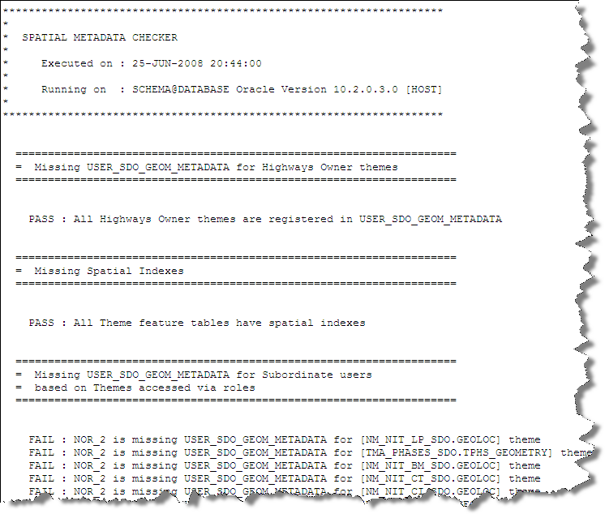
Theme Check – Example Output
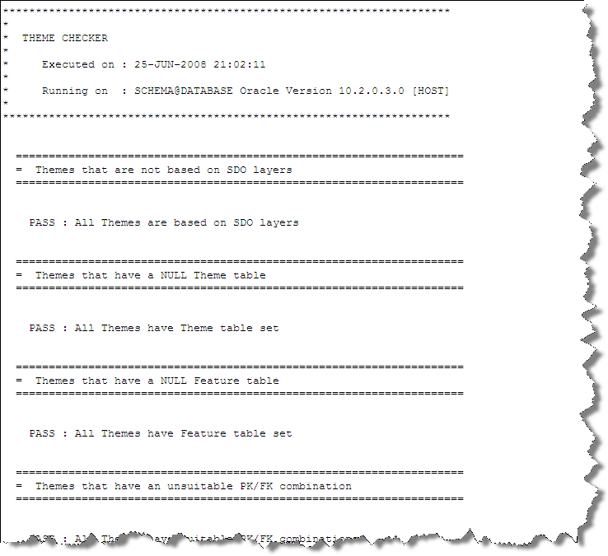
SDE Check – Example Output
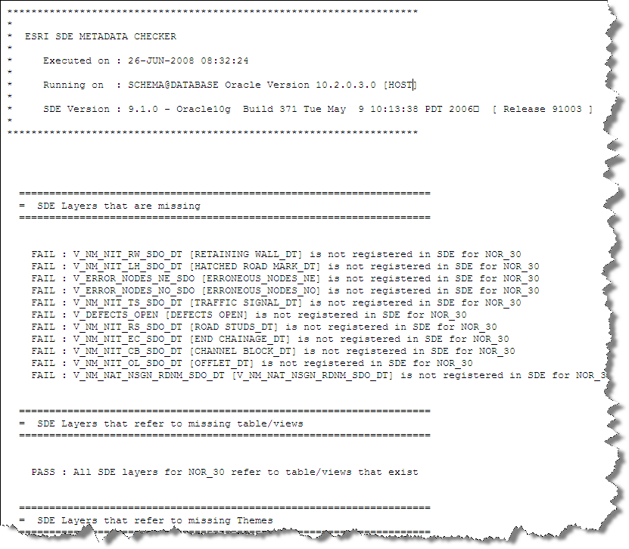
  - Performance Changes
There have been a series of performance enhancements made to the server code many of which are due in part to extensions within the Oracle Optimiser. In particular the changes to the server code will affect spatial searches on date-tracked and join views; this includes snapping (nearest neighbour) searches as well as area or buffer searches. This should result in swifter operation of Exor web maps as well as better performance in spatial operations embedded within other products such as Street Gazetteer Manager when generating placements for associated street data. Also, inside this product the suppression of spatial indexes until further into a process has led to improved spatial performance in the generation of associated street data shapes.

Web map performance has been improved during the starting process although this was shipped as an earlier patch on 4.0.4 systems it has been back-ported into Core Highways version 4.0.2.1. Also rolled into this release are improvements in the way that private synonyms are handled and this could make a significant difference to customers who make use of private synonyms especially during installation and upgrades.

Some improvements have been made in the execution of the Exor Feature Selection tool inside Spatial Manager. This change may not be significant in cases where the feature is composed of many spatial fragments. Under these circumstances, the client libraries that are outside of Exor control will feed the selected object identifiers into a table and perform queries using poorly composed optimiser hints. The resulting poor performance is outside of exor control.

The performance of the creation of metadata and access to spatial objects has been improved and in some cases this will be noticed and be significant. However, some code relies on externally available APIs and performance may not be sparkling when these are utilised. It is not unreasonable for the maintenance of themes and roles and user access to themes to take several minutes depending on the number of themes and users configured in the system.

  - Support for Quad Tree Indexes
The software in this release is aimed at minimising the occurrence of deadlocks due to Oracle R Tree index problems on the 9i platform. This bug is fixed in Oracle 10 platforms and it is recommended that customers move to Oracle 10g and the appropriate Exor system release. However, if this is not possible, the 4.0.2.1 release will minimise the deadlocks. It is recommended that this release is executed using R Tree indexes. However, if deadlocks persist, the system supports the use of Quad Trees by default after the setting of product options. These will not be supported on later releases. See the section on the use of Quad Trees.
  - Date tracking dynamically segmented layers.
The creation of asset or non-linear group layers has been improved to include historical network data. This will only take effect on those network elements for which a shape is present in the spatial feature table even if this shape represents a closed/end-dated network element. This historical data will remain invisible in GIS systems when displayed using the date-tracked views.
  - Other Changes
Previous patches that are also back-ported into Core Highways version 4.0.2.1 include the foreign key indexes on the DOCS table. The impact of not having these indexes is significant to users of Maintenance Manager Works Ordering when used in tandem with Public Enquiry Manager. Their inclusion may improve performance generally to some extent whereas in this specific case performance is improved due to significant reduction in locks and the prevention of deadlocks.

The Reclassify function has been improved to avoid cached variables preventing the use of the function more than once in any session. This affects internal processing only and has no impact on the application that is available from within SM or Oracle Forms.

- Log No. Summary
This chapter summarises all Software Bugs and Changes that have been made in this release. These changes are derived from the following sources,

- Customer raised issues

Please note that this is not a full list of the issues that may be cleared as a result of this release. There may be other exor issues that are cleared as a result of the changes to the metadata and these will be cleared during the near future.

  - Customer Raised Issues

Support Call No | Issue
714511 | Create new asset in Spatial manager and asset shape does not appear on the map
714166 | Entering a defect in a web map, snapping to the network fails with “No network found within tolerance”
714410 | Trying to add a new element or reshape in SM the following message appears on SAVE:- Error description: ORA-01776 cannot modify more than one base table through a join view ORA-06512: at HIGHWAYS.NM3SDO, line 4792 ORA-06512 at HIGHWAYS.NM3SDM, line 702 ORA-06512
710193 | Correction to reference-post, correcting the error message: Net-0444: Reference asset types must be point and allowed on the network for the network location.
714216 | Highways owner must display a spatial layer before a subordinate user can gain access. The result “'Layer is not loaded”. This issue may be compounded by the fact that ESRI clients cache the metadata and the user may need to exit and restart to refresh the ESRI cache. The exor themes cache can be refreshed via the right-mouse click on the SM table of contents.
714413 | On reshape of a datum element existing linear asset shapes still follow the old network shape.
713894 | Reshape datum element results in “Error Description: ORA-02292: integrity constraint (HIGHWAYS.NADL_NE_ID_FK) violated -child record found  ORA-06512: at "HIGHWAYS.NM£SDM", line 3356  ORA-06512: at line 1”
713915 | Oracle error when attempting reshape.  ORA-01752: Cannot delete from view without exactly one key-preserved table.
713421 | Failure to locate assets in Spatial Manager
713308 | PK violation on edit. Relates to NSG metadata only.

- Addendum for Correction in case of Deadlocks.
The Oracle 9i Spatial system is flawed in the way that multiple spatial edits may manifest themselves with transaction locks on a metadata table and this can result in deadlocks.

The exor core highways system has a mechanism in the spatial server that allows dependent dynamically segmented shapes in multiple tables to be kept in-sync with the shape of the base network. When base-network shapes change, the system will operate on dependent themes where the nth_update_od_edit = ‘I’. This update is in a fixed sequence yet the locking mechanism of Rtree indexes in Oracle 9i may take transaction locks on the index metadata table at any stage and therefore there is a risk of deadlocks and this is outside the control of Exor code.

It is thought that the use of Quad Tree indexes may resolve this problem. However, the locking of the index metadata is more common when combinations of DML such as delete followed by an insert are within a single transaction. This release has changes within it to minimise the potential for deadlocks, but these may still result. Hence it is recommended that if upgrading to 10g is not an option then R trees (default) should be used. However, If deadlocks persist, the option remains to revert to Quad Tree indexing and scripts are provided for this purpose.

  - Test Script
To test if this may be an issue, some simple SQL scripts can be used. The tables that need to be accessed in this test depend on those tables that are configured in the system. Use this simple query first to establish the name and relevant columns of the driving table. The result in this example is an extract of three separate datum layers, each being a base table:

SQL> l
1 select nth_theme_id, nth_feature_pk_column, nth_feature_shape_column, nth_feature_table
2 from nm_themes_all, nm_nw_themes, nm_linear_types
3 where nlt_g_i_d = 'D'
4 and nth_base_table_theme is null
5 and nlt_id = nnth_nlt_id
6 and nnth_nth_theme_id = nth_theme_id
7* order by nlt_nt_type
SQL> /

NTH_THEME_ID NTH_FEATURE_PK_COLUMN NTH_FEATURE_SHAPE_COLUMN NTH_FEATURE_TABLE
------------ ------------------------------ ------------------------------ -------------------------
224 RSE_HE_ID SHAPE HIGHWAYS_NET_MAP_D_TABLE
226 NE_ID SHAPE NM_NSG_ESU_SHAPES_TABLE
225 RSE_HE_ID SHAPE HIGHWAYS_NET_MAP_L_TABLE

The theme 225 was chosen for the test, on the test system there were several immediately updatable asset themes that were dependent on the theme 225. This means that as a result of a reshape within this layer, several other tables would be updated.

To perform the test, construct two separate SQL scripts, each of which is identical except for the order. This will allow each script to operate on distinct sets of shapes where one would not normally experience a locking problem. Modify the script below to reference the name of the network feature table and modify the join criteria to be consistent with your system data from the SQL above. This one uses the ascending order; construct another script using the descending order. Use SQL*Plus and execute each script in separate sessions simultaneously. The scripts only update a shape of a datum element to itself so there is no risk of corruption of data.

declare
cursor c1 is
select rse_he_id, shape
from highways_net_map_l_table, nm_elements
where ne_id = rse_he_id
and rownum < 20
order by rse_he_id asc;
begin
for irec in c1 loop
nm3sdm.RESHAPE_ELEMENT(irec.rse_he_id, irec.shape);
end loop;
commit;
end;

Without the 4.0.2.1 changes, it is highly likely that one transaction will fail as shown below whilst the other completes successfully.

ERROR at line 1:
ORA-29876: failed in the execution of the ODCIINDEXDELETE routine
ORA-13209: internal error while reading SDO_INDEX_METADATA table
ORA-29400: data cartridge error
ORA-00060: deadlock detected while waiting for resource
ORA-06512: at "MDSYS.SDO_INDEX_METHOD_9I", line 210
ORA-06512: at line 1
ORA-06512: at "DORSET.NM3SDO", line 4012
ORA-06512: at "DORSET.NM3SDM", line 976
ORA-06512: at line 10

If after the 4.0.2.1 patch, this example fails to produce a deadlock, then it is recommended that the system continues to employ R Tree indexing. If deadlocks persist, then the system can be configured to use Quad Tree indexing by the setting of appropriate system options. These may be configured using the default values using the SQL script supplied. See 4021_product_options.sql. Please note that these options will not be supported on Oracle 10g platforms. Care should be taken to ensure that the tiling level is of a reasonable size. Although Oracle supply procedures

  - Converting R Tree Indexes to Quad Trees
This patch contains a script to remove a set of R Tree indexes and replace them with Quad Trees. Quad Tree indexes are notoriously sensitive to dimension metadata and often, rounding errors close to the boundary can generate Oracle spatial errors when attempts are made to generate the Quad Tree. It is important therefore that the diminfo for each spatial table is sufficiently large to bound all geometries in the table.

See the procedure REPLACE_R_WITH_Q_TREES. This procedure accepts a default tiling level which may be replaced if necessary.

  - Converting Quad Tree indexes to R Trees
The exclusive locks on index metadata tables when using R Tree indexing is no longer a problem in the Oracle platforms that are certified for exor systems after 4.0.2.1. These are based on Oracle RDBMS 10.2.0.3 and above. Preparation for the transition to Oracle 10gR2 should include the replacement of the Quad Trees with R tree indexes. A script to revert them is also supplied.

See the procedure REPLACE_Q_WITH_R_TREES

